**Q.1. (2 marks)** Let g(x)=x3+x+1. Consider the information sequence 1001. Find the codeword corresponding to the preceding information sequence. Using polynomial arithmetic we obtain:

**Answer:**

Step 1: Add 000 to data bits string. It will be 1001000

Step 2: Devide 1001000 to 1011 in modulo – 2 method.

1001000 1011

1011

01000

1011

00110

Codeword = 1001110

**Q2. (2 marks)**

Consider the 7-bit generator, G=10011, , and suppose that D has the value 1001010101. What is the value of R? Show your all steps to have result.

***Note: Explain your answer in details***

**Answer:**

The value of *D+r* is 10010101010000 is taken by previous problem.

Consider the value, *D*=1001010101

Now dividing *D+r* with *G* the value of *R* is:

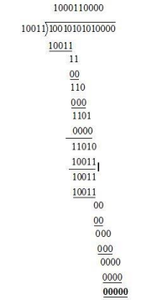

**So, R value is 0000**

**Q.3. (2 marks)**

Suppose two hosts, A and B, are separated by 20,000 kilometers and are connected by a direct link of R = 2 Mbps. Suppose the propagation speed over the link is 2.5 x 108 meters/sec.

a. Calculate the bandwidth-delay product, R _ dprop.

b. Consider sending a file of 800,000 bits from Host A to Host B. Suppose the file is sent continuously as one large message. What is the maximum number of bits that will be in the link at any given time?

***Note: Explain your answer in details***

**Answer:**

a)

The distance (Distance) between two hosts A and B = 20,000 km



Trasmission rate(R) of the direct link between A and B =2Mbps



Propagation Speed(S) of the link between A and B Calculate the propagation delay:



Calculate the band-width delay product:



Therefore, band-with delay product is 160000bits

b)

Size of the file =800000 bits 

Trasmission rate(R) of the direct link between A and B =2Mbps



The band-width delay product:



Therefore, the maximum number of bits at a given time will be 160000bits. **Q.4. (2 marks)**

A packet switch receives a packet and determines the outbound link to which the packet should be forwarded. When the packet arrives, one other packet is halfway done being transmitted on this outbound link and four other packets are waiting to be transmitted. Packets are transmitted in order of arrival.

Suppose all packets are 1,500 bytes and the link rate is 2 Mbps. What is the queuing delay for the packet? More generally, what is the queuing delay when all packets have length *L*, the transmission rate is *R*, *x* bits of the currently-being-transmitted packet have been transmitted, and *n* packets are already in the queue?

***Note: Explain your answer in details.***

**Answer:**

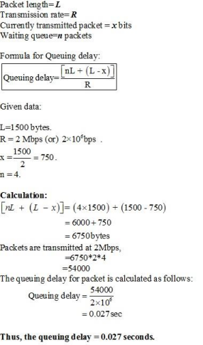

**Q.5. (2 marks) A router has the following CIDR entries in its routing table:** *Address/mask Next hop*

135.46.56.0/22 Interface 0

135.46.60.0/22 Interface 1

192.53.40.0/23 Router 1

default Router 2

(a) What does the router do if a packet with an IP address 135.46.63.10 arrives? **Answer:**

Taking the first 22 bits of the above IP address as network address, we have 135.46.60.0.

It matches the network address of 135.46.60.0/22. So, the router will forward the packet to Interface 1.

(b) What does the router do if a packet with an IP address 135.46.57.14 arrives? **Answer:**

Taking the first 22 bits of the above IP address as network address, we have 135.46.56.0.

It matches the network address of 135.46.56.0/22. The packet will be forwarded to Interface 0.

**Note:**

- **Students have to follow the steps and complete the tasks in details in order to have the results. If the students only write the result, that is, that result is not marked or recorded.**

- **Students do examination on paper and answer by English**